Conduit Gateway Setup Guide

# First initialization

Connecting into the gateway’s operative system:

* Connect USB, wait until discovered and installed by host computer.
* Connect Ethernet cable to router and the gateway
* Connect power cable. Wait until “status” led is blinking.
* Download and install “Tera Term” on host computer. Run the program and select “Serial”, and select “COM??: ”. Press ok.
* Press any key. Log in with user name: “root” and password “root”

Establishing internet access <http://www.multitech.net/developer/software/mlinux/getting-started-with-conduit-mlinux/> :

Setting with a static IP:

* After logged into the operative system, type vi /etc/network/interfaces
* Press “insert” button on keyboard and find and change the address and netmask fields to the router settings.
* Press “Esc” button once and type in :wqthen press enter.
* To apply changes, either reboot the device or issue: ifdown eth0 && ifup eth0
* Type ping 8.8.8.8 to test for internet access.

Using DHCP to find IP (recommended):

* After logged into the operative system, type vi /etc/udhcpd.conf
* Press “insert” button on keyboard and find and change the IP address range you want to search on. This can vary depending on the router setup.
* Press “Esc” button once and type in :wqthen press enter.
* Start the DHCP, issue: mlinux-dhcpd restart
* Type ping 8.8.8.8 to test for internet access.

Starting MQTT communication <http://www.multitech.net/developer/software/lora/conduit-mlinux-lora-communication/>

* Type cd /home/ then node lora-sample-app.js
* The communication should start running. After about 10 s, two messages should appear, “Connected locally, subscribing” and “Connected server”. If both doesn’t show up there is something wrong, and the messages will not be sent. If “connected server” doesn’t come up, likely scenarios are:
  + The Gateway doesn’t have internet access, go back to ensure there is an internet access by using the ping command.
  + The server address isn’t correctly set, edit lora-sample-app.js and make sure you have the correct IP address as your server.
  + The server might not be running, make sure it is running.
* You can exit the running program by pressing “Ctrl+C”.
* The conduit should be shut down by issuing shutdown –hH now then you can cycle the power on/off.

# Setting up a factory reset Gateway

Setting up network server: <http://www.multitech.net/developer/software/lora/getting-started-with-lora-conduit-mlinux/>

* Connect into the gateway’s operative system, see under “First initialization” above
* Type these commands into the conduit:
  + mkdir /var/config/lora
  + cp /opt/lora/lora-network-server.conf.sample /var/config/lora/lora-network-server.conf
  + vi /var/config/lora/lora-network-server.conf
* Now you can edit the lora-network-server configuration. Use “insert” button to edit, then change the configuration to be as in figure :

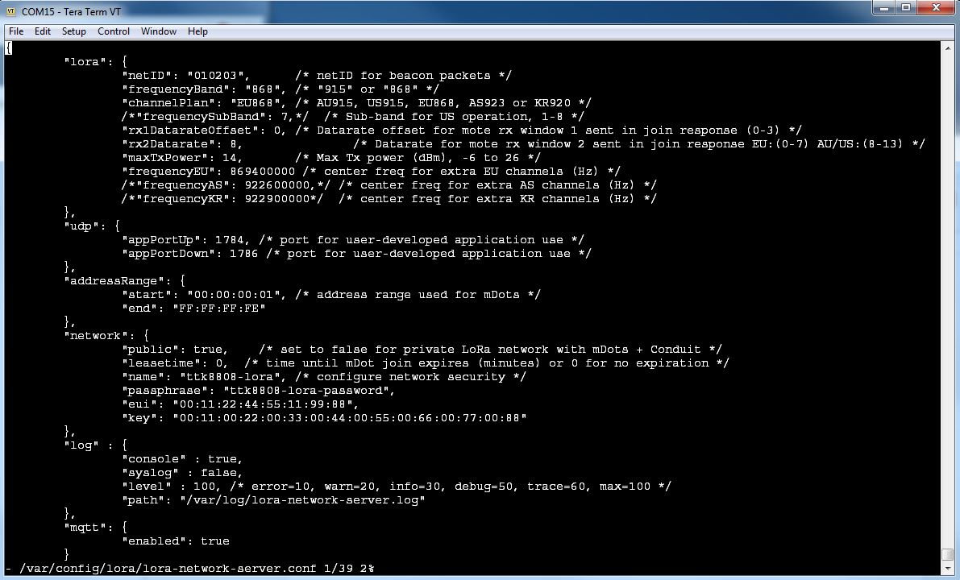

* When finished, press “Esc” button once and type in :wqthen press enter to save
* Restart the network server with /etc/init.d/lora-network-server restart

Creating packet forwarder using MQTT: <http://www.multitech.net/developer/software/lora/conduit-mlinux-lora-communication/>

* SCP into the conduit, and transfer the pre-built